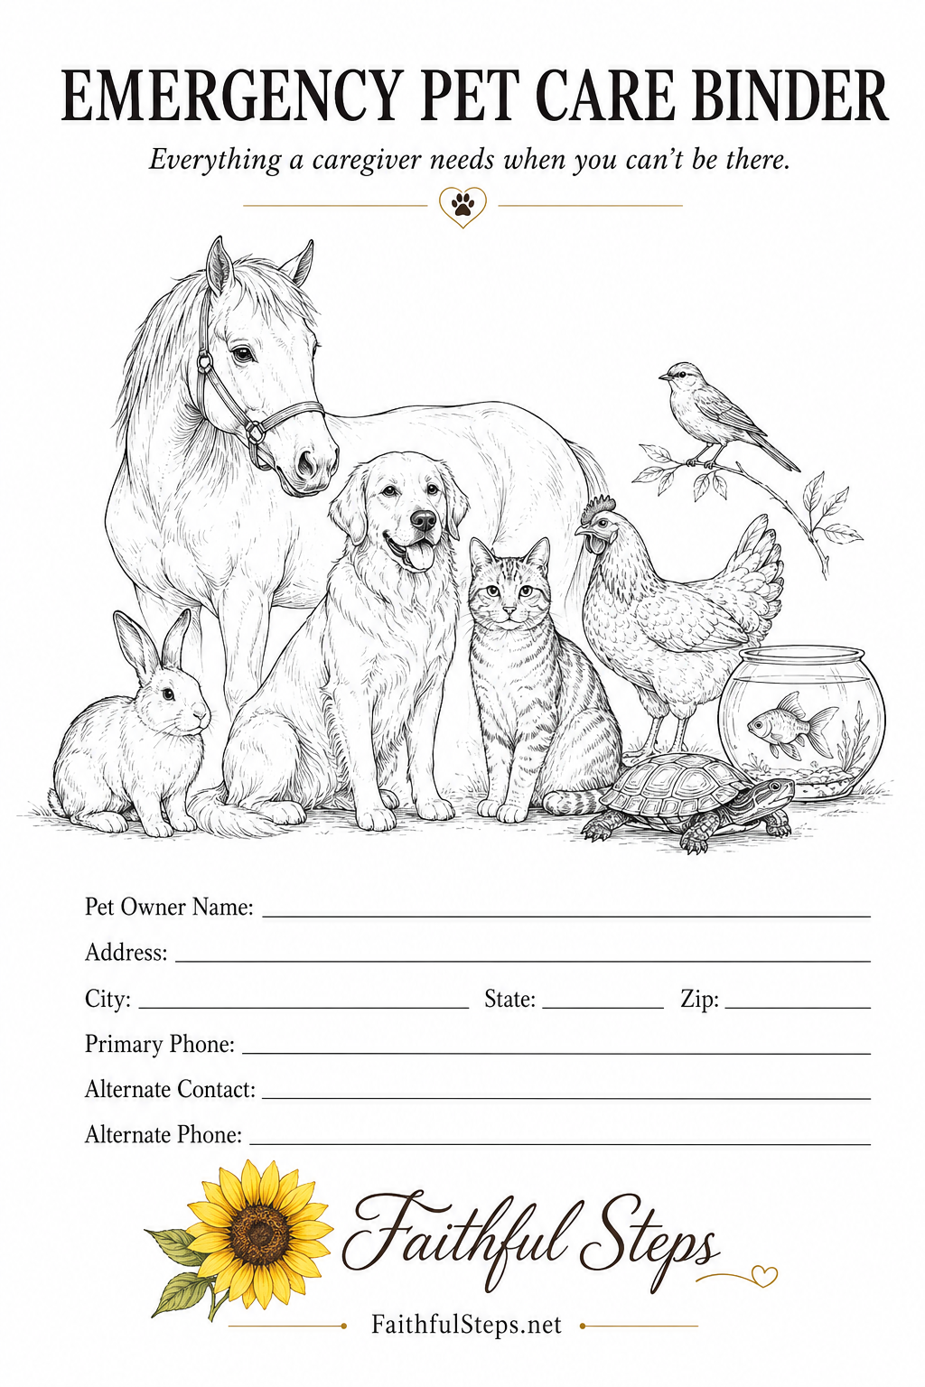

EMERGENCY QUICK REFERENCE — CONTACTS & SPECIAL CARE
Keep this page where a caregiver can find it immediately.
Owner Information
Owner Name _____________________________________________
Primary Phone _____________________________________________
Secondary Phone _____________________________________________
Emergency Contacts
Primary Contact / Relationship _____________________________________________
Phone _____________________________________________
Secondary Contact / Relationship _____________________________________________
Phone _____________________________________________
Veterinary Care
Primary Veterinarian / Clinic _____________________________________________
Phone _____________________________________________
24-Hour Emergency Veterinarian / Clinic ___________________________________________
Phone _____________________________________________
Pet Insurance
☐ Yes ☐ No
Insurance Company _____________________________________________
Policy / Member # _____________________________________________
Claims / Contact Phone _____________________________________________
Animals Requiring Immediate or Special Care
Pet / Animal | Special Need / Immediate Instruction

EMERGENCY QUICK REFERENCE — IMPORTANT ITEMS
Keep this page with the Contacts & Special Care quick-reference page.
Home Entry
House Key / Entry Instructions _____________________________________________
Spare Key / Contact _____________________________________________
Pet Care Supplies
Pet Food _____________________________________________
Medications _____________________________________________
Treats / Supplements _____________________________________________
Leashes / Harnesses _____________________________________________
Carriers / Crates _____________________________________________
Emergency & Cleaning Supplies
Pet First-Aid Supplies _____________________________________________
Cleaning Supplies _____________________________________________
Towels / Bedding _____________________________________________
Waste / Litter Supplies _____________________________________________
Other Important Items
Item / Location _____________________________________________
Item / Location _____________________________________________
Item / Location _____________________________________________
Brief Emergency Instructions
______________________________________________________________________
______________________________________________________________________
If the owner cannot be reached, contact the emergency person listed on the matching quick-reference page and follow the animal-specific instructions in this binder.

HOME & CAREGIVER INFORMATION
Home Information
Home Address _____________________________________________
Owner Name(s) _____________________________________________
Primary Phone _____________________________________________
Secondary Phone _____________________________________________
Getting Into the Home
Key Location _____________________________________________
Spare Key With / Phone _____________________________________________
Door / Gate Instructions _____________________________________________
☐ Alarm System: Yes ☐ No
Alarm Code Location / Instructions _____________________________________________
Important Household Information
Item | Location / Notes
Electrical panel
Main water shutoff
Emergency supplies
Pet first-aid supplies
Cleaning supplies
Extra pet food / supplies
Household & Pet Rules
Animals that must NOT be together _____________________________________________
Doors / gates that must remain closed _____________________________________________
Rooms / areas pets must not enter _____________________________________________
Animal Count & Quick Check
Total animals expected _____________________________________________
Group / outdoor animals and number expected _____________________________________________
Animals that may hide / where to look _____________________________________________
Before You Leave
☐ All animals accounted for ☐ Food/water provided ☐ Medications given
☐ Doors/gates/enclosures secure ☐ Equipment checked ☐ Concerns logged
INDIVIDUAL PET PROFILE
Repeat this page for each individually cared-for pet.
Pet's Name _____________________________________________
PHOTO  Attach a clear, recent photo | Animal / Species: __________________  Breed: ___________________________  Color / Markings: _________________  Sex: ☐ Male ☐ Female  Spayed/Neutered: ☐ Yes ☐ No  Age / DOB: ______________________  Weight: _________________________  Microchip #: _____________________  Registry: ________________________
Get to Know Me
My personality _____________________________________________
I really like _____________________________________________
I don't like _____________________________________________
Things that frighten or upset me _____________________________________________
Best way to comfort or calm me _____________________________________________
Please Know This About Me
Please be especially careful when _____________________________________________
Important behavior / handling notes _____________________________________________
Words & Commands I Know
Command / Word | Means
Where I Belong
During the day _____________________________________________
At night _____________________________________________
When no one is home _____________________________________________
If I Get Loose or Hide
What gets my attention _____________________________________________
Places I may hide / go _____________________________________________
DAILY CARE & MEDICAL INFORMATION
Repeat this page for each individually cared-for pet.
Pet's Name _____________________________________________
⚠ ALLERGY ALERT Known allergies? ☐ No ☐ Yes — see below
Feeding & Water
Food / Brand / Amount _____________________________________________
Morning / Afternoon / Evening _____________________________________________
Treats Allowed _____________________________________________
Do NOT Feed _____________________________________________
Water Location / Instructions _____________________________________________
Bathroom / Walk / Exercise
Schedule / Instructions _____________________________________________
Leash / Harness Location _____________________________________________
Litter / Potty / Enclosure Cleaning _____________________________________________
Medications
Medication | Dose | Time | How Given
Medications Located _____________________________________________
If a Dose Is Missed, Contact / Phone _____________________________________________
Allergies & Important Reactions
Food Allergies _____________________________________________
Medication Allergies _____________________________________________
Environmental / Other _____________________________________________
Known Reaction / Vet Instructions _____________________________________________
Medical Information
Known Conditions _____________________________________________
Major Surgery / Injury _____________________________________________
Mobility / Physical Limitations _____________________________________________
Call Me or the Veterinarian If ____________________________ (See Vet Section)
GROUP & SPECIALTY ANIMAL CARE — CARE INSTRUCTIONS
Print this 2-page set for each group as needed.
Animal Type _____________________________________________
Group Name _____________________________________________
Number of Animals _____________________________________________
Location / Enclosure _____________________________________________
Daily Care
Morning _____________________________________________
Afternoon _____________________________________________
Evening _____________________________________________
Other Routine / Frequency _____________________________________________
Food
Food / Brand / Type _____________________________________________
Amount _____________________________________________
Feeding Frequency _____________________________________________
Food Location _____________________________________________
Do NOT Feed _____________________________________________
Water
Water Source / Location _____________________________________________
Refill / Cleaning Instructions _____________________________________________
Supplements & Routine Supplies
Supplements / Minerals _____________________________________________
Amount / Frequency _____________________________________________
Supplies Located _____________________________________________
Care Notes
Special Routine _____________________________________________
Other Instructions _____________________________________________

GROUP & SPECIALTY ANIMAL CARE — HEALTH & EMERGENCY
Keep this page with the matching Care Instructions page.
Animal Type / Group Name _____________________________________________
Enclosure & Environment
Cleaning / Bedding / Substrate _____________________________________________
Temperature / Heat _____________________________________________
Lighting / Humidity _____________________________________________
Fencing / Gate / Enclosure _____________________________________________
Equipment That Must Remain On _____________________________________________
Health & Safety
Allergies / Sensitivities _____________________________________________
Medications / Treatments _____________________________________________
Normal Behavior _____________________________________________
Signs Something May Be Wrong _____________________________________________
Handling Precautions / Do NOT _____________________________________________
Counting & Daily Checks
Expected Number / How Often to Count _____________________________________________
If One Is Missing _____________________________________________
Items to Collect / Remove / Check _____________________________________________
What to Do With Them _____________________________________________
Veterinary / Emergency Contact
Veterinarian / Specialist _____________________________________________
Phone _____________________________________________
Emergency Clinic / Phone _____________________________________________
Emergency Instructions________________________________________________________
___________________________________________________________________________________

EMERGENCY & EVACUATION PLAN
In an immediate life-threatening emergency, call 911.
Owner / Phone _____________________________________________
Primary Emergency Contact / Phone _____________________________________________
Evacuation Destination
Primary Location / Address / Phone _____________________________________________
Alternate Location / Address / Phone _____________________________________________
Transportation
Primary Vehicle _____________________________________________
Person Who Can Help / Phone _____________________________________________
Carriers / Crates Location _____________________________________________
Leashes / Harnesses Location _____________________________________________
Horse / Livestock Trailer Information _____________________________________________
Evacuation Supplies
☐ Food ☐ Water ☐ Bowls ☐ Medications ☐ Leashes/Harnesses
☐ Carriers/Crates ☐ Records ☐ First Aid ☐ Waste Supplies ☐ Bedding
Supply Location _____________________________________________
Special Evacuation Help
Pet / Animal | Special Instructions
Animals That Must Be Separated
Animals / Reason / Instructions _____________________________________________
If I Cannot Return Home
Temporary Care Person / Phone _____________________________________________
Backup Person / Phone _____________________________________________
Important Documents
Pet / Vaccination Records _____________________________________________
Insurance / Ownership Records _____________________________________________
VETERINARY TREATMENT AUTHORIZATION
Pet Owner _____________________________________________
Address _____________________________________________
Phone _____________________________________________
Authorized Caregiver
Name / Relationship / Phone _____________________________________________
Alternate Authorized Person
Name / Relationship / Phone _____________________________________________
Animals Covered ☐ All animals listed in this binder ☐ Only these animals:
Animals _____________________________________________
If I cannot be reached, I authorize the person named above to seek veterinary examination and treatment for my animal(s), subject to the instructions and limitations below.
Veterinary Care
Preferred Veterinarian / Clinic / Phone _____________________________________________
24-Hour Emergency Clinic / Phone _____________________________________________
Treatment & Financial Instructions
Other Instructions _____________________________________________
Maximum amount caregiver may authorize without reaching me: $ _______________
Payment Arrangements / Instructions _____________________________________________
Pet Insurance ☐ Yes ☐ No
Company / Policy # _____________________________________________
Major Medical / End-of-Life Decisions
Contact Person / Phone _____________________________________________
My Wishes / Additional Instructions _____________________________________________
Owner Authorization
Owner / Caregiver | Signature | Date
Owner:
Authorized Caregiver:
This page records emergency-care wishes. Veterinary clinics may require their own authorization, payment, or consent forms.
CAREGIVER DAILY LOG
Repeat for each day or visit as needed.
Date / Caregiver / Arrival / Departure _____________________________________________
How Did Today Go?
______________________________________________________________________
______________________________________________________________________
Food & Water
☐ Fed as instructed ☐ Fresh water checked ☐ Treats as allowed
Changes in appetite / drinking _____________________________________________
Medications & Treatments
Missed / refused / delayed / different _____________________________________________
Pet / Time / What Happened _____________________________________________
Bathroom / Walks / Exercise
Anything Unusual _____________________________________________
Behavior & Well-Being
Changes / Concerns _____________________________________________
Household / Animal Area Check
Supplies Running Low _____________________________________________
Contacted Today
☐ No ☐ Owner ☐ Emergency contact ☐ Veterinarian ☐ Other
Reason / Instructions Received _____________________________________________
Notes for Owner or Next Caregiver
______________________________________________________________________
______________________________________________________________________
Caregiver Signature / Initials _____________________________________________

LONG-TERM & PERMANENT CARE WISHES
If I am unable to resume caring for my animals, these are my wishes for their continued care.
First Person I Want Contacted
Name / Relationship / Phone / Email _____________________________________________
☐ Agreed to care for animals ☐ Agreed to help arrange care ☐ Still need to discuss
Alternate Person
Name / Relationship / Phone / Email _____________________________________________
☐ Agreed to care for animals ☐ Agreed to help arrange care ☐ Still need to discuss
My Wishes
Animals That Should Remain Together _____________________________________________
Animals That May Be Placed Separately _____________________________________________
Special Placement Instructions _____________________________________________
People / Places I Do NOT Want Used _____________________________________________
Rescue / Sanctuary
Organization / Contact / Phone / Email / Website _____________________________________________
Instructions _____________________________________________
Financial Arrangements
Contact / Phone _____________________________________________
Attorney / Trustee / Executor _____________________________________________
Important Documents Location _____________________________________________
Personal Belongings
Special Items / Location _____________________________________________
Anything I Want a Future Caregiver to Know
______________________________________________________________________
______________________________________________________________________
This page records your wishes and is not a substitute for a will, pet trust, power of attorney, or other legal document.

IMPORTANT DOCUMENTS & RECORDS
Record where important originals or copies are kept. Avoid sensitive passwords or financial account information.
Record | Included / Location
Vaccination records
Rabies certificate
Medication / prescription information
Medical / surgical records
Veterinary treatment authorization
Microchip information
Pet license / registration
Ownership records
Recent photographs
Pet Insurance
Location / Company / Policy # / Claims Phone _____________________________________________
Specialty Records
Location / Notes _____________________________________________
Digital Records
Where / Access Instructions Location _____________________________________________
Emergency Copies
☐ Emergency contact has records ☐ Vet has authorization
☐ Long-term caregiver has information ☐ Copies in evacuation supplies
Last Updated
Reviewed On _____________________________________________
Next Review Planned _____________________________________________

LOST PET EMERGENCY INFORMATION
First, do not assume the animal has left the property. Check the Individual Pet Profile for hiding places and ways to get their attention.
If a Pet Is Missing
☐ Check home, yard, buildings, and enclosures
☐ Secure doors, gates, windows, and fencing
☐ Contact owner/emergency contact
☐ Check microchip information
☐ Contact local shelter/animal control
☐ Report missing to microchip registry
☐ Contact veterinarian if appropriate
☐ Use a recent clear photo
Description, photo, microchip number, and identifying information are on the Individual Pet Profile.
Owner's Special Instructions
______________________________________________________________________
______________________________________________________________________
Places They Are Likely to Go _____________________________________________
People / Neighbors They Know _____________________________________________
Local Lost-Pet Resources
Animal Control _____________________________________________
Local Shelter _____________________________________________
Other Resource _____________________________________________
Notes
______________________________________________________________________
______________________________________________________________________

BINDER READY CHECKLIST & UPDATE RECORD
☐ Emergency contacts current
☐ Veterinary/emergency clinic info current
☐ Pet insurance included if applicable
☐ Home access/key instructions current
☐ Every animal included in count
☐ Each pet has current profile/photo
☐ Microchip info current
☐ Feeding instructions current
☐ Medication names/doses/schedules current
☐ Allergies clearly identified
☐ Medical/special needs current
☐ Behavior/handling instructions included
☐ Group/specialty instructions complete if needed
☐ Carriers/leashes/emergency supplies easy to locate
☐ Evacuation plan current
☐ Vet authorization completed
☐ Emergency caregivers know they are listed
☐ Long-term caregivers contacted
☐ Important records can be located
☐ Blank Caregiver Daily Logs included
People Who Have a Copy or Know Where the Binder Is
Name | Phone
Update Record
Date Reviewed | What Changed? | Initials
Review whenever medications, medical conditions, feeding routines, contacts, caregivers, or household animals change.

